

|  |  |  |  |  |  |  |  |  |
| --- | --- | --- | --- | --- | --- | --- | --- | --- |
|  | | | | | | | | |
|  | | Sequence Diagrams | | | | |  | |
|  |  | | | | | | |  |
|  | | | |  | |  | | |
|  | | | | Muhammad Talha(Lead)Zohaib ZafarAbdul RehmanGroup 12 | |  | | |
|  | | | | Date24 March 2025Course titleSoftware ConstructionTeacher’s NameDr. Onaiza Maqbool | |  | | |
|  | | |  | |  | | | |

**Name: Muhammad Talha**

**Reg. No: 04072312004**

**System Sequence Diagram**

**(Request Complaint)**

The Request Complaints use case enables users (Students or Teachers) to submit complaints about laboratory issues. The user accesses the complaint form, fills in the details, and submits it. The system validates the input, saves the complaint to the database, and displays a success message. If there’s an error (e.g., invalid input), the system shows an error message, prompting the user to retry. This process ensures efficient issue reporting and tracking.

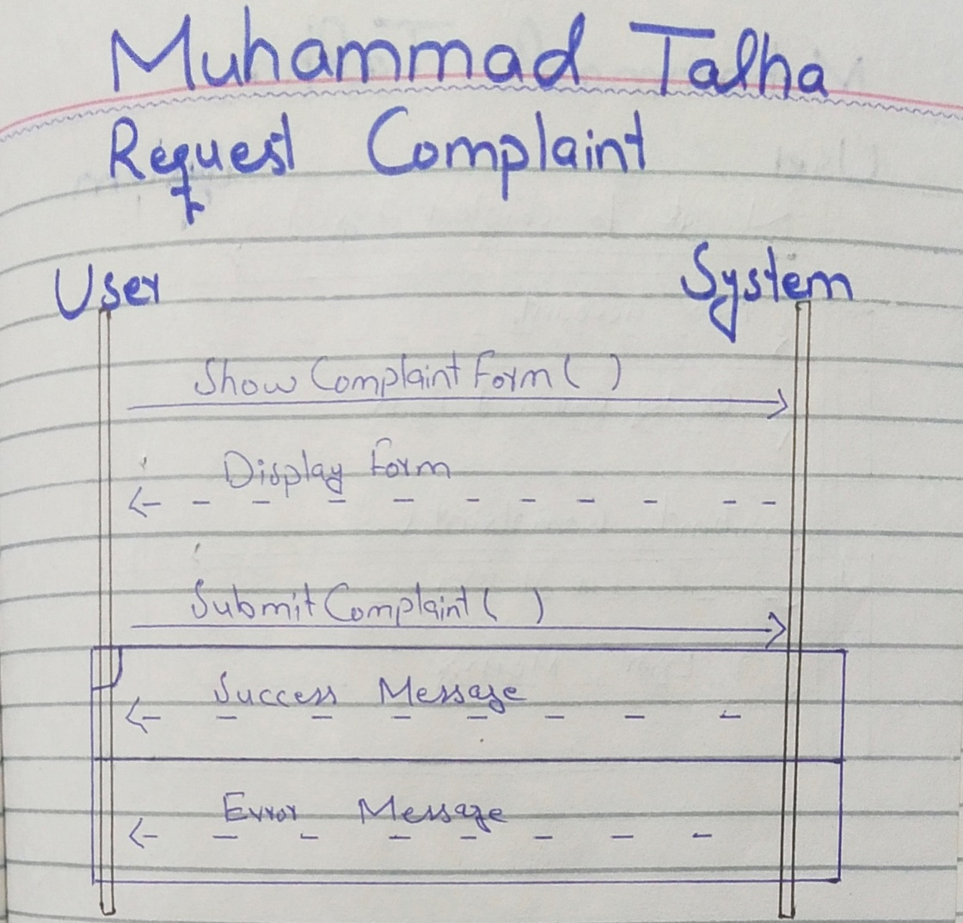

**System Sequence Diagram**

**(Manage Complaint)**

The Manage Complaints use case allows the admin to handle complaints submitted by users. The admin can view all complaints, filter pending ones, and identify important issues. They can also update the status of complaints (e.g., from "Pending" to "Resolved"). The system displays relevant information and confirms status updates, ensuring efficient complaint management and resolution tracking.

